**Scenario’s** covered in the performance test plan are listed below.

1. Home page
2. Review landing page
3. Review detail page
4. Interview landing page.
5. Interview detail page.
6. Job Landing page.
7. Insight Landing page.
8. TBSL Company landing page.
9. HCL Company landing page.
10. TCS Company landing page.

We had run the load on three test plan.

1. LOAD TESTING- 100 concurrent user load with 3 min rampup time.
2. LOAD TESTING- 150 concurrent user load with 3 min rampup time.
3. SOAK TESTING- 150 concurrent user load with 3 min rampup time with 3 hrs continuous load.

Environment used:

Windows 7 Professional.

Server Config is 2 CPU (2900 Mhz) 16GB RAM.

Tool : Jmeter 2.13

**150 concurrent user with 3 hrs continuous load on the JB server site**.

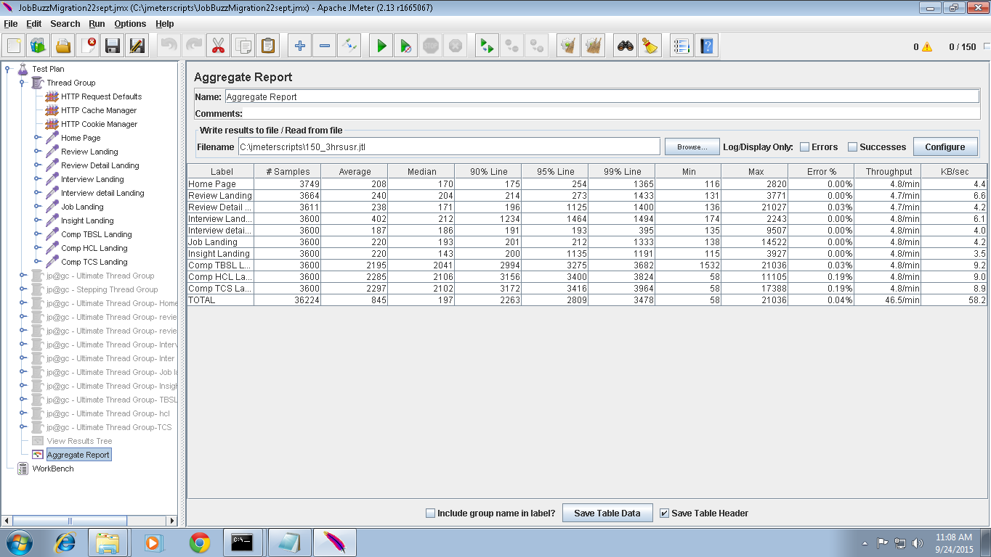

**Results shows 0% error.**

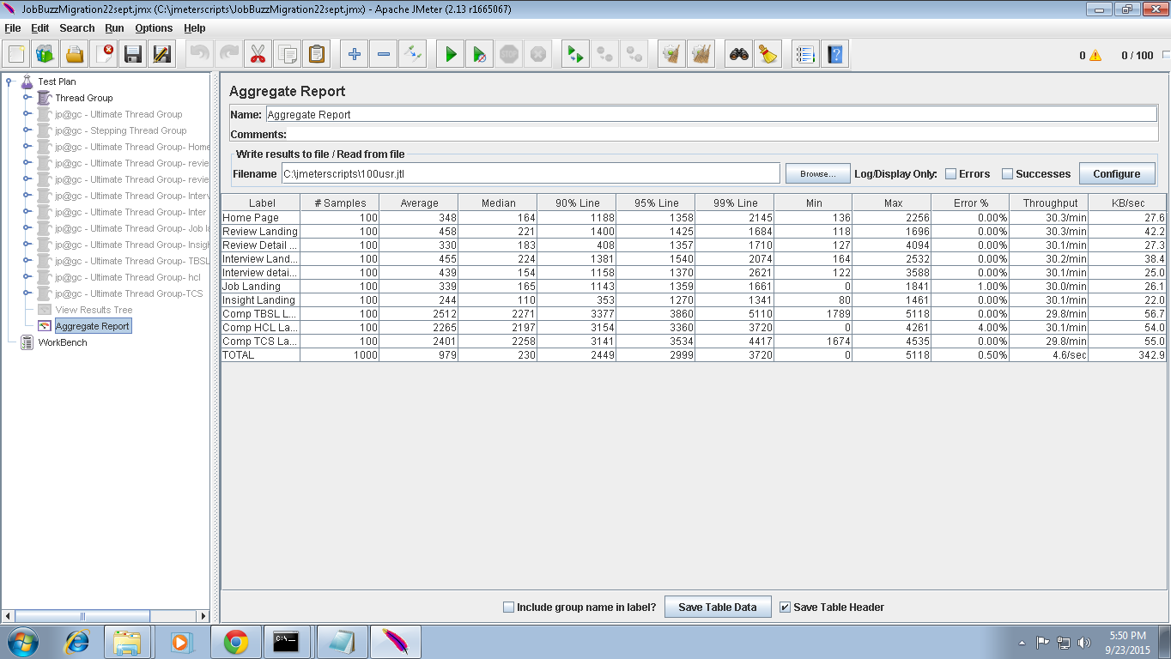

**100 concurrent user load for JB with 100 rampup time** .

**Result shows 0% error report. Few error % can be ignored which is less than 2%.**

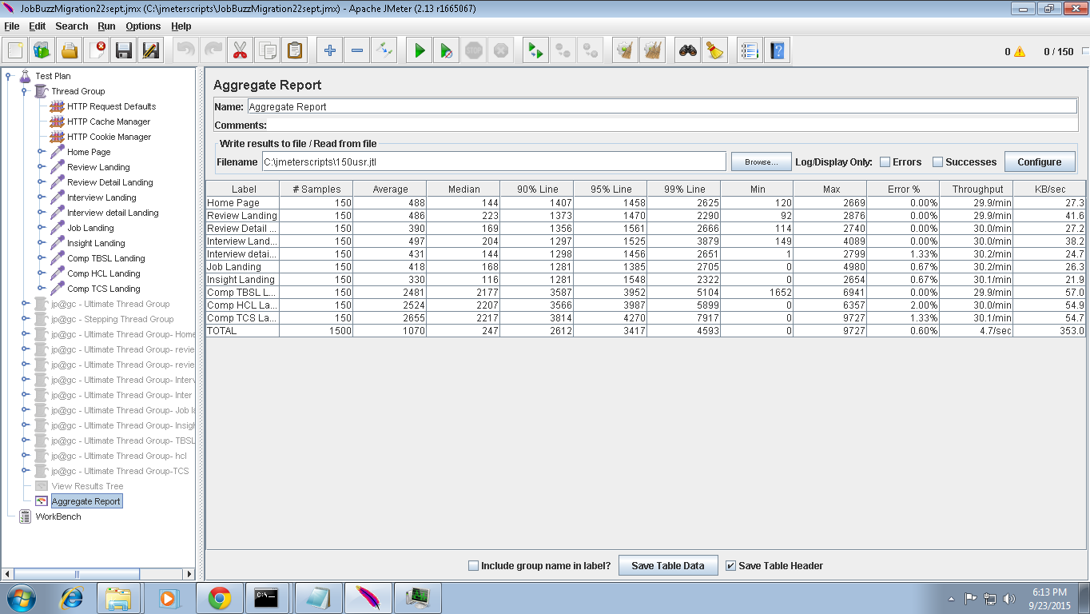

**150 concurrent user with 3 min rampup time.**

**Result shows 0% error report.**

**150 concurrent user with 3 hrs continuous load on the JB server site**.



**Results shows 0% error.**